Vibrating String
HyperPhysics
http://hyperphysics.phy-astr.gsu.edu/hbase/waves/string.html


Vibrating String
The fundamental vibrational mode of a stretched string is such that the wavelength is twice the length of the string.
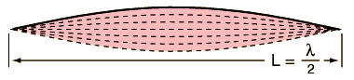
Applying the basic wave relationship gives an expression for the fundamental frequency:
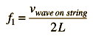 | Calculation

Since the wave velocity is given by | 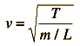 | , the frequency expression
can be put in the form:
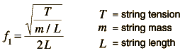
The string will also vibrate at all harmonics of the fundamental. Each of these harmonics will form a standing wave on the string.
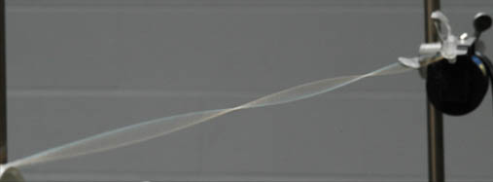
This shows a resonant standing wave on a string. It is driven by a vibrator at 120 Hz.
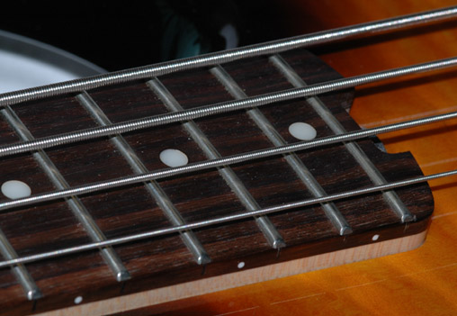
For strings of finite stiffness, the harmonic frequencies will depart progressively from the mathematical harmonics. To get the necessary mass for the strings of an electric bass as shown above, wire is wound around a solid core wire. This allows the addition of mass without producing excessive stiffness.
Example measurements on a steel string
String frequencies | String instruments | Illustration with a slinky |  | Mathematical form

Measurements with a steel string
The fundamental frequency of a stetched string is given by
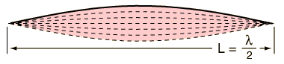
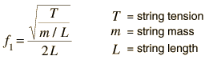 | Calculation
A brief data set with a steel string is plotted to check the consistency of the data with the above equation. Hanging masses provide the tension in the string, which was adjusted to a vibrating length of 50 cm.
 | 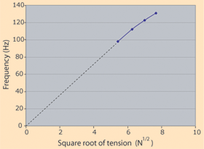
  Hanging Mass | Tension | Frequency
  3 kg | 29.4 N | 98 Hz
  4 kg | 39.2 N | 112 Hz
  5 kg | 49 N | 122.5 Hz
  6 kg | 58.8 N | 131 Hz
This is obviously not an ideal string since the best straight line fit of the data of frequency vs square root of tension would not pass through zero frequency at zero tension. If that fact is ignored for the moment and the average slope of the line through zero is taken, the slope is 17.6 Hz/N^{1/2}. Using the frequency relationship above, this corresponds to a mass per unit length m/L = 57 grams/meter.

String Instruments
 | 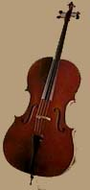  Cello
  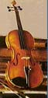
  Violin
  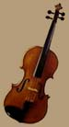
  Viola
  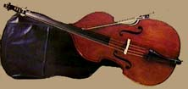
  Double Bass
  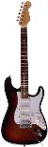Electric Guitar | 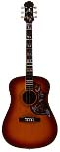Guitar

String properties | String excitation | String instrument resonances
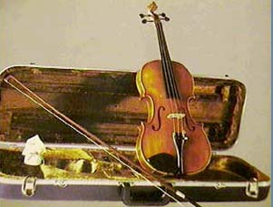 |  |  | The Violin  The violin, the most commonly used member of the modern string family, is the highest-sounding instrument of that group.  The strings are tuned a fifth apart at G3(196 Hz), D4, A4, E5(659.3 Hz). Strings characteristically produce a fundamental resonance plus all the string harmonics. The sound of the instrument is enhanced by body resonances including the air resonance of the f-holes.
  Violin details

Wave Velocity in String
The velocity of a traveling wave in a stretched string is determined by the tension and the mass per unit length of the string.
The wave velocity is given by | 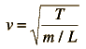
  Show
When the wave relationship is applied to a stretched string, it is seen that resonant standing wave modes are produced. The lowest frequency mode for a stretched string is called the fundamental, and its frequency is given by
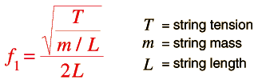
From velocity = sqrt ( tension / mass per unit length )
the velocity = m/s
when the tension = N = lb
for a string of length cm and mass/length = gm/m.
For such a string, the fundamental frequency would be Hz.
Any of the highlighted quantities can be calculated by clicking on them. If numerical values are not entered for any quantity, it will default to a string of 100 cm length tuned to 440 Hz. Default values will be entered for any quantity which has a zero value. Any quantities may be changed, but you must then click on the quantity you wish to calculate to reconcile the changes.
Derivation of wave speed

Harmonics
An ideal vibrating string will vibrate with its fundamental frequency and all harmonics of that frequency. The position of nodes and antinodes is just the opposite of those for an open air column.  The fundamental frequency can be calculated from  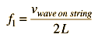  where  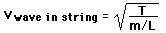  and the harmonics are integer multiples.  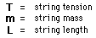 | 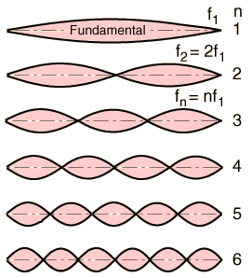

Illustration with a slinky

Vibrating String Frequencies
If you pluck your guitar string, you don't have to tell it what pitch to produce - it knows! That is, its pitch is its resonant frequency, which is determined by the length, mass, and tension of the string. The pitch varies in different ways with these different parameters, as illustrated by the examples below:
*with the other parameters reset to their original values. | 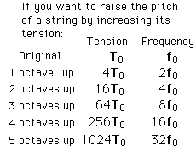
  If you have a string with starting pitch: | 100 Hz
  and change* to | the pitch will be
  double the length | 50 Hz
  four times the tension | 200 Hz
  four times the mass | 50 Hz

Calculation

Some Violin Details
The violin, the most commonly used member of the modern string family, is the highest-sounding instrument of that group. Its four strings are stretched over a high arched bridge that permits the playing of one or two strings at a time, as well as the nearly simultaneous sounding of three or four as chords. The overall length of the violin averages about 60 cm (23.5 in), whereas the sounding length of the strings, from bridge to the nut at the end of the fingerboard, is about 32 cm (12.75 in). The instrument is held on the left side of the body, while the right hand holds the bow. The wider end of the instrument is placed between the player's left shoulder and chin, while the left hand encircles its neck, the fingers stopping the strings to produce the various pitches. Sound is produced by drawing the bow across the strings to make them vibrate, or by plucking the strings (PIZZICATO).
The range of the violin extends from G, the lowest open string, upward nearly four octaves. The strings are tuned a fifth apart at G3(196 Hz), D4, A4, E5(659.3 Hz).
Many consider that violin making reached its pinnacle in the work of Antonio Stradivari and Guiseppe Guarneri in the 18th century. Although the basic construction of the violin has been long established, the subtle variations which make an outstanding violin are the stuff of legend.
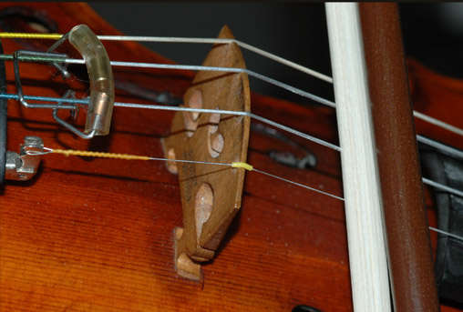
The sound quality can be changed considerably by the place where the string is bowed. If bowed close to the bridge (sul ponticello) then the sound is brighter with more harmonic content. If bowed further from the bridge (sul tasto) then the sound is darker, more mellow with less harmonic content.
Violin illustration

Violin Construction
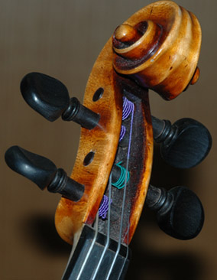 | The modern violin consists of about seventy parts. Parts include the belly, the back, the ribs, inside blocks, inside lining, bass bar, purfling, finger board, neck, scroll, nut, lower nut, tailpiece, loop, end button, pegs, strings, bridge, and the sound post. The body of the violin is a hollow box which measures about 35.5 cm in length. The back, the neck, the ribs and the bridge are usually made of maple. The belly, linings, and the soundpost are usually made of spruce. Scrupulous care is taken in selecting and shaping the belly and back. They must be adjusted to certain frequencies before assembly in order for the main wood resonance of the instrument to be of the apppropriate strength and pitch.

Violin Bridge
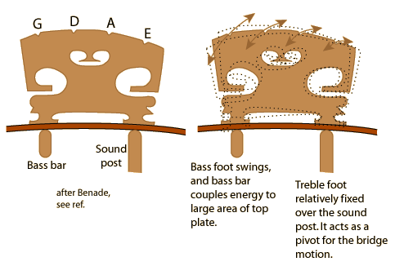
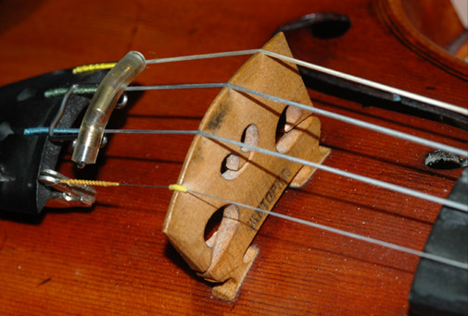
The action of the violin bridge is essential to the tone of the instrument. It's shape and function have been developed over centuries. Underneath the treble side of the bridge (where the E string rests) is the sound post which extends from the front to the back plate of the instrument. Since this side of the bridge rests on this post, it is essentially fixed and acts as a pivot for the rocking motion of the remainder of the bridge. It does however, couple the sound energy from the top plate to the back plate of the instrument.
Underneath the bass side of the bridge (where the G string rests), a long, thin wooden strip called the bass bar is attached, almost parallel to the strings. This bass foot of the bridge is more free to move, and its motion is the point of transfer of energy from the strings to the top plate of the instrument. The extended bass bar helps it to transfer the energy to a larger area of the top plate. As can be seen from the diagram, the amplitude of motion is larger for the bass strings. This is desirable for balance of loudness, since the sensitivity of the ear drops off a bit toward the lower frequencies of the instrument.

